# Code Branch Process

## *Owner: John.Zhang, Backup: Harvey.Chen*

## Version No. Format:

Servlet: xx.xx.x.xxx

Rserver: Vxx.xx.xxx

CUI: Vxx.xx.xxx

## Step 0: Before create code branch, please email to .ActiveNet Development to let all ANet guys know.

Prior to the code branch being done an email must be sent out to the team letting them know when it is going to happen. Be sure to include the documentation team (Charissa Wall) as there are things they do after the branching is complete.

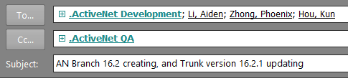

Hi All,

I will do the code branch for 16.1.2 and upgrade current Git develop to 16.2 task from 10:30AM China time.

Please do not check-in any changes into Git develop at this time. Will send an e-mail to let you know when will done.

## Step 1: [Release Branch] Create for current version:

**[Will update when do 17.1 release branch]**

### Do an “Update” in the local trunk to make sure all the latest changes are downloaded.

### Create the branch in SVN

#### Branches should use following format

<https://fndsvn.dev.activenetwork.com/ActiveNet/branches/ActiveNet2014Q3>  
<https://fndsvn.dev.activenetwork.com/ActiveNet/branches/ActiveNet2014Q3_05>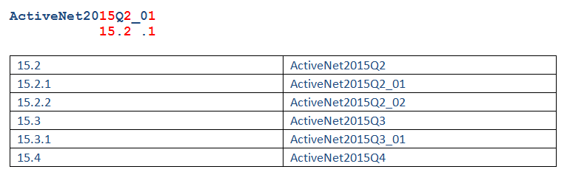

#### Right click the trunk on your local machine and select Branch/tag

16.1.2 Branch name: 2016Q1_02

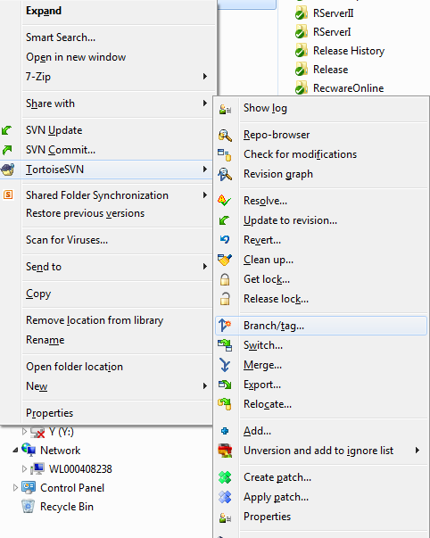

Specify the name of the branch you want to create, and add a message like “Branch for 14.5”

Hit OK. The branch will be created.

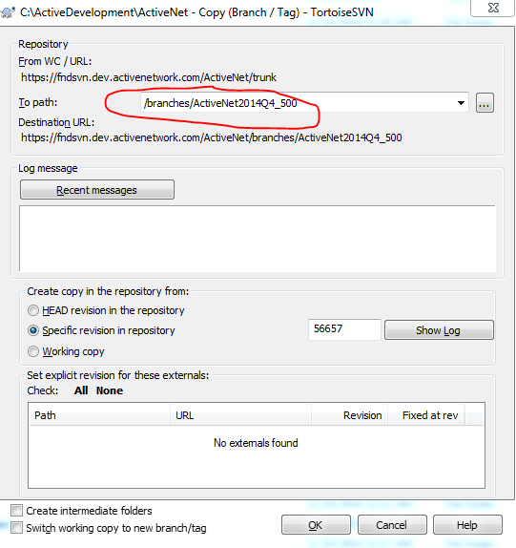

## Step 2: [Trunk] Upgrade version

GitLab: <https://gitlab.dev.activenetwork.com/groups/ActiveNet>

### Upgrade version in:

activenet-package, apd-interface-emv, apd-interface-emv-elavon, and pass-production projects:

Such as: 16.12.0.1, 16.20.0.1, 16.21.0.1

* 1. Modify **build.xml** file in folder.

|  |
| --- |
| <property name="ivy.deliver.revision" value="16.12.0.1-SNAPSHOT"/> |

* 1. Commit these changes into Git.
  2. **Login** <http://jenkinsm-01w.aw.active.tan:8080/job/Release-Libs-Gitlab/>

To build above projects, we can click ‘[Build with Parameters](http://anjenkinsm.dev.activenetwork.com:8080/view/Linux-View/job/Release-Lib/build?delay=0sec)’.

Always use ‘ActiveNetPackage’ as APPNAME, just change the GITPATH, and please make sure always use ‘develop’ for BRANCH:

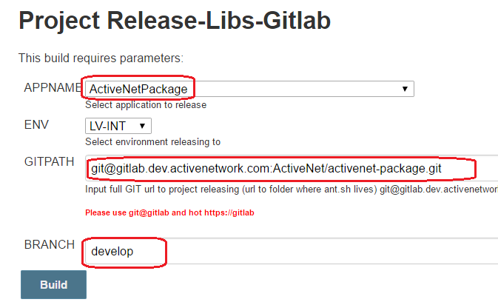

*If build fail, please click ‘build No.’ to see detail info:*

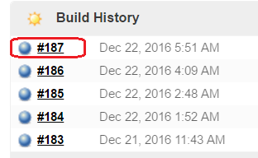

* 1. *Jenkins errors, connect with Platform Team B, they will work to fix with (Howard.Gao, Kun.Hou):*
* [*BuildTools*](https://fndsvn-01w.dev.activenetwork.com/foundations/core/buildtools/trunk) *error:*

*Like 16.2 version update, NA check in some code changes for BuildTools that can’t work with ANet code. Finally, we asked Kun.Hou use old version BuildTools for ANet Jenkins as temp solution, in same time, Nan pop up the issue to NA BuildTools related devs.*

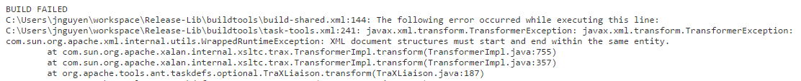

* *Publish *.jar FAILED:*

*Rebuild above 4 project maybe meet this issue, as old one have be published, so you need to update version No. in* ***build.xml****, such as: if old version is 16.20.0.2, then update it to 16.20.0.4.*



### Update ‘point-of-sale’:

* 1. Modify **build.xml** file in folder.

|  |
| --- |
| <property name="ivy.deliver.revision" value="16.12.0.1-SNAPSHOT"/> |

* 1. Update **ivy.xml (**keep with same as dependency’s version in build.xml**)**

<dependency org="com.active.anet" name="activenetpackage" rev="16.31.0.1" transitive="false" />

* 1. Commit these changes into Git.
  2. **Login** <http://jenkinsm-01w.aw.active.tan:8080/job/Release-Libs-Gitlab/>

Start build above projects, we can click ‘[Build with Parameters](http://anjenkinsm.dev.activenetwork.com:8080/view/Linux-View/job/Release-Lib/build?delay=0sec)’ link.

### Modify ivy.xml file under ‘activenet-servlet’ folder, modify related version for above projects to current version (such as: 16.20.0.1).

C:\ActiveNet\ActiveNetServlet\

Update dependency’s version No. to same with the version in their build.xml.

|  |
| --- |
| <dependency org="com.active.services.anet" name="PassProduction" rev="16.12.0.1" transitive="false" />  <dependency org="com.active.services.anet" name="PointOfSale" rev="16.12.0.1" transitive="false" />  <dependency org="com.active.services.anet" name="APDEMVInterfaceApplet" rev="16.12.0.1" transitive="false" />  <dependency org="com.active.anet" name="activenetpackage" rev="16.12.0.1" transitive="true" />  <dependency org="com.active.services.anet" name="APDEMVElavonInterfaceApplet" rev="16.21.0.1" transitive="false" /> |

*[Note: for this part, if we need unify the version for other package, like EntryPointApplet, we should replay step #1.]*

### Update servlet version to current version in build.xml file which under the ‘activenet-servlet’ folder.

C:\ActiveNet\activenetservlet\

Such as: V16.20.0.0.001-, V16.12.0.0.001-

|  |
| --- |
| <property name="ivy.deliver.revision" value="16.21.0.0.001-SNAPSHOT"/> |

### Bump up schema level by 10 in trunk.

### SystemInfo.java needs to be updated and Data Scripts of DATABASE_ATTRIBUTES.sql needs to be updated.

required_schema_level

C:\ActiveNet\activenet-servlet\src\ANServlet\

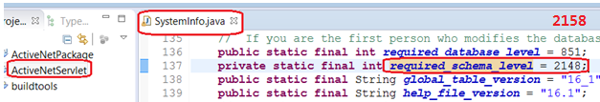

C:\ActiveNet\activenet-servlet\KitManager\Databases\ActiveNet\DataScripts**\**

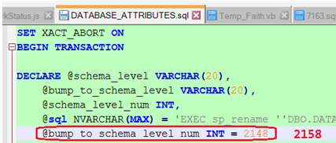

* **Schema level validator ‘**[schema_level_validator.sql](https://fndsvn.dev.activenetwork.com/ActiveNet/trunk/ActiveNetServlet/KitManager/Databases/ActiveNet/Database/schema_level_validator.sql)**’**

C:\ActiveNet\ActiveNetServlet\KitManager\Databases\ActiveNet\Database

Keep the “@min_schema_level_num” as pre-version value of “@bump_to_schema_level_num” in “DATABASE_ATTRIBUTES.sql”:

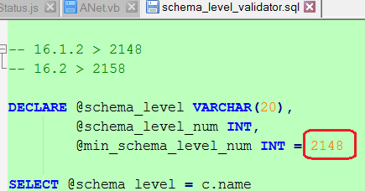

***[Notes:]*** *For now, if the targeted database is out of date, an error will be thrown and Jenkins will stop the rest DB deployment steps.*

### Bump up database level by 10 in trunk. SystemInfo.java and DBUpdateScript.java need to be updated.

C:\ActiveNet\activenet-servlet\src\ANServlet

We will leave 10 gaps for new branch. Such as:

Release branch version is: 16.1.2,

Current db_level is 838,

Trunk version is 16.2.0.

We will use 838 – 848 as 16.1.2 branch gap maintenance in future, and:

Doesn’t need to add any code and changes in release branch 16.1.2

To update ‘required_database_level’ to 848 in Trunk,

To add related code in Trunk.

Then Trunk will use db level start from 849.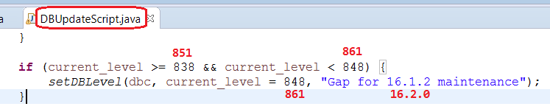

### EmailService.

Open project

C:\ActiveNet\email-service

Change version in **assemblyInfo.vb** and **StaticVars.vb** to new version number. Change the **output binary file name** to the new version.

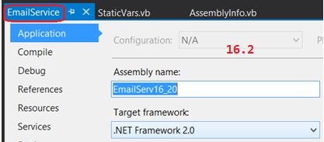

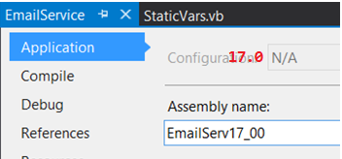

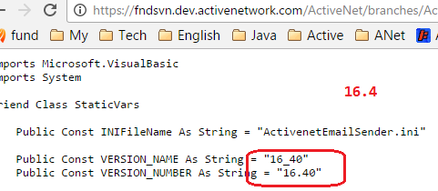

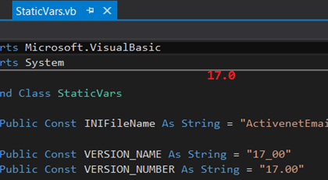

Copy new “*.exe” from “C:\ActiveNet\EmailService\EmailService\bin\” to “C:\ActiveNet\EmailService\”.  
Check in binary file into Git.

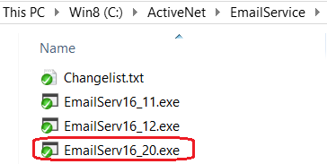

[**Richard**] *Deploy the new version email service in INT environment in anintbulkmail01 (10.219.160.109). Go to D:\ActiveNet\_EmailService. Copy new binary file there and create new batch files for the new version. Run the install batch to create a service for the new version.*

## Step 3 Kit-Manager Update:

#### 1 Login into <https://kitmanager.dev.activenetwork.com/Home/>

[How to work with Kit-Manager?](https://fndsvn.dev.activenetwork.com/ActiveNet/trunk/ActiveNetServlet/KitManager/README.md#3)

[Kit-Manager work with Git](https://gitlab.dev.activenetwork.com/ActiveNet/dev-document/blob/develop/KitManager%20%20Supports%20GitLab%20now.docx).

After merge to git, the project name should be update to same as Kit Manager in “**kitrunner.yaml**” files.

ANet Dev to finish this part work, then let DBE do review.

[Can get help from [Phoenix.Zhong@activenetwork.com](mailto:Phoenix.Zhong@activenetwork.com) or Erik.Liu]

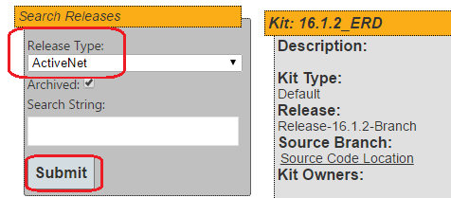

#### 2 Create Kit for ActiveNet

##### **2.1 For Branch Release (such as: 16.1.2):**

* **Create Release:**

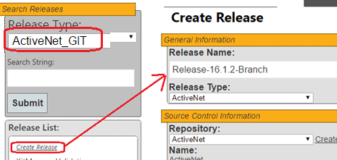

**Source Code Path (**need to update red part to right branch**):**

tree/**activenet2016qX**/KitManager/

**Deployment Path:**

tree/**activenet2016qX**/KitManager/Deployment/

* **Create Kit for Branch**

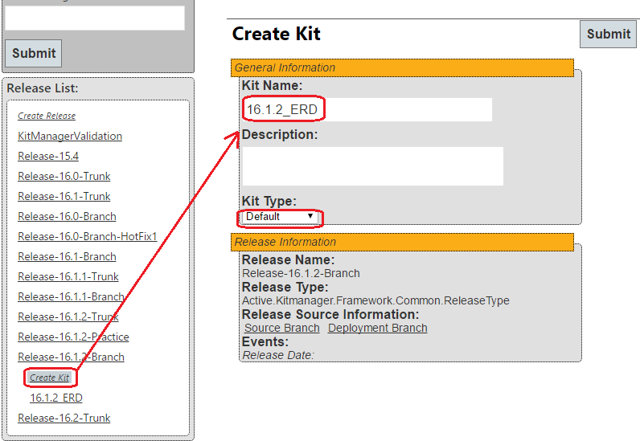

* **Add all the previous added files** to this kit. Refresh the kit:

Please use the raw address, You can get the raw address for a file by clicking the “**Raw**” button when you browser the particular file in GitLab:

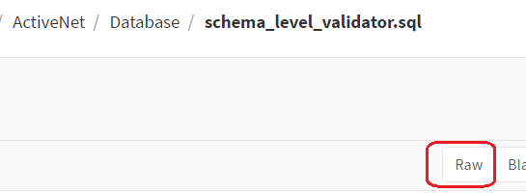

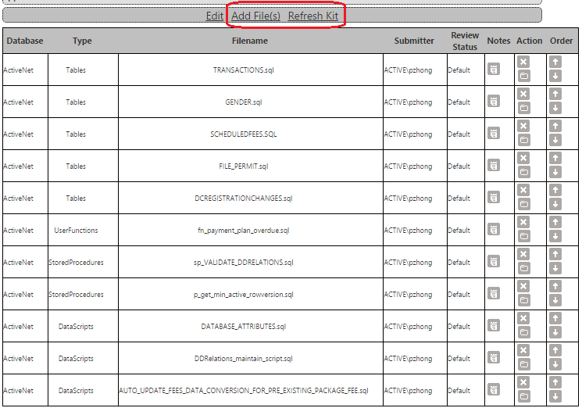

Then click ‘Refresh Kit’

* **Update the kit # in kitrunner.yaml**

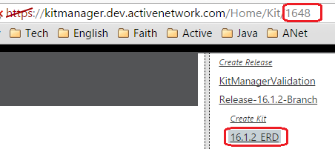

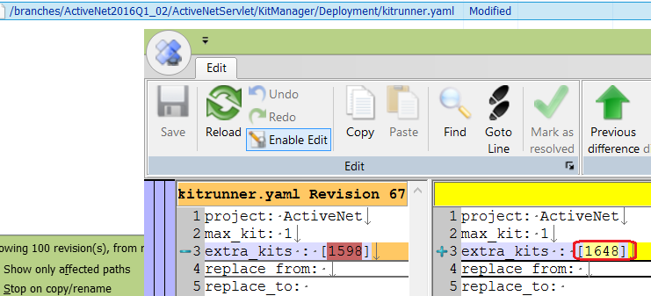

##### **2.2** **Create for Trunk (such as: 17.1)**

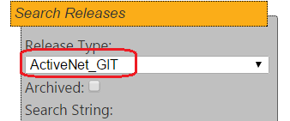

* Path:

**Source Code Path:**

tree/develop/KitManager/

**Deployment Path:**

tree/develop/KitManager/Deployment/

* For Trunk – Kit, just need to add files:

<https://gitlab.dev.activenetwork.com/ActiveNet/activenet-servlet/raw/develop/KitManager/Databases/ActiveNet/Database/schema_level_validator.sql>

<https://gitlab.dev.activenetwork.com/ActiveNet/activenet-servlet/raw/develop/KitManager/Databases/ActiveNet/DataScripts/DATABASE_ATTRIBUTES.sql>

Then click ‘Refresh Kit’:

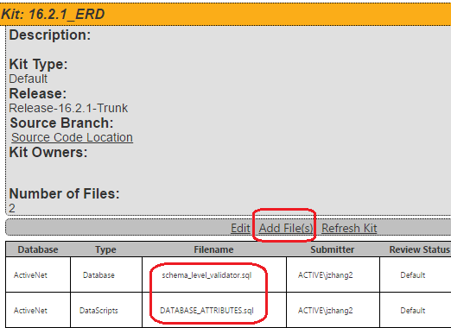

* Update “C:\ActiveNet\ActiveNetServlet\KitManager\Deployment\**kitrunner.yaml**”

#### 3 Create Kit for ActiveNetSites

Similar with #7.2 (Branch and Trunk)

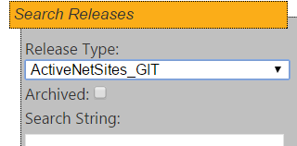

* Branch

**Source Code Path (**need to update red part to right branch**):**

tree/**activenet2016qX**/KitManager/

**Deployment Path:**

tree/**activenet2016qX**/KitManager/Deployment/

Update the kit # in kitrunner.yaml

* Trunk

**Source Code Path:**

tree/develop/KitManager/

**Deployment Path:**

tree/develop/KitManager/Deployment/

* Update \ActiveNetSites \KitManager\Deployment\**kitrunner.yaml**” for both Trunk and Release Branch.

#### 4 Create Kit for ActiveNetLogs

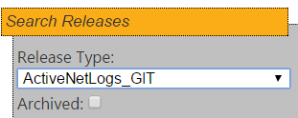

* Branch

**Source Code Path (**need to update red part to right branch**):**

tree/**activenet2016qX**/KitManager/

**Deployment Path:**

tree/**activenet2016qX**/KitManager/Deployment/

Update the kit # in kitrunner.yaml

* Trunk

**Source Code Path:**

tree/develop/KitManager/

**Deployment Path:**

tree/develop/KitManager/Deployment/

* Update \ActiveNetLogs\KitManager\Deployment\**kitrunner.yaml**” for both Trunk and Release Branch.

#### 5 Create RollBack Kit for Release Branch (Both ActiveNet and ActiveNetSites)

* Per Phoenix’s suggestion: named this Kit as Pre-Version-No._SnapShot_ERD, and added it under Pre-Version branch. As we want to rollback changed SP/SF to Pre-Version (need point the file to Pre-Version SVN URL path). Such as, for 16.2 RollBack (16.2’ Pre-Version is 16.1.2):

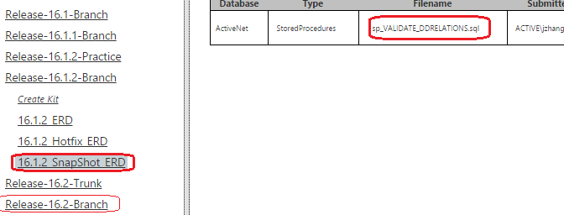

* Only to add SP/SF that exists in Pre-Version, and changed in new version. File path need to point to Pre-Version released branch.

SF = User Function

**How to find the changed existing SP/SF, such as for 16.2:**

Go through all SP/SF that added in 16.2 Kit, try to search them in 16.1.2 release SVN branch, if you can find it, then please add it in RollBack Kit.

* **Don’t** need to update **kitrunner.yaml**

## Step 4: [Trunk] Following only applies to major releases (16.1.2 -> 16.2 for example).

1. Change version in SystemInfo.java  
   Open SystemInfo.java, upgrade “global_table_version” and “help_file_vesion” to new version.

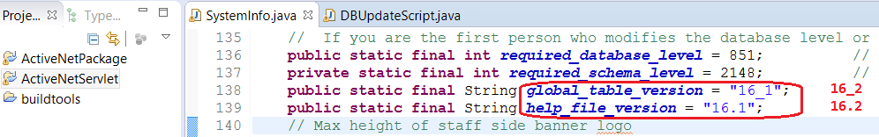

1. Customizable List in ‘LoadCustomizableLists.sql’  
   [C:\ActiveNet\db-schema](https://fndsvn.dev.activenetwork.com/ActiveNet/trunk/DBSchema/LoadCustomizableLists.sql)  
   Change all “version” (total about 205) in the file from old version to new version.

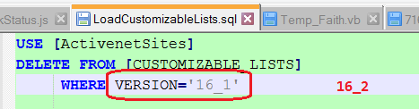

*[****Richard****] Apply the change in ActiveNetSites db in INT environment.*

## Step 3: Help Site

Updated by Li, Aiden[**Aiden.Li@activenetwork.com**](mailto:Aiden.Li@activenetwork.com)

## Step 4: [Done] email to all

After the branch is done the build process needs to be updated so be sure to send an email to Richard Cheng to confirm he will take care of it.

Hi All,

16.1.2 Branch created.

We just created one branch for 16.1.2 and upgraded trunk to version 16.2, below are the detailed information:

**16.1.2** -- <https://fndsvn.dev.activenetwork.com/ActiveNet/branches/ActiveNet2016Q1_02/>

This is for 16.1.2, if you have any issues regarding 16.1.2, please commit here and remember merge back to develop.

**16.2** -- develop now is for 16.2.

**Kit Manager:**

16.1.2 branch: <https://kitmanager.dev.activenetwork.com/Home/Kit/1648>

16.2 develop: <https://kitmanager.dev.activenetwork.com/Home/Kit/1649>

If you have any questions, please feel free to ask.

## Step 5: database template update (Tom.Qin)

After latest version ANet released, we need to get the latest database (ActiveNetStartup.BAK, ActiveNetTrainer.BAK) from Burnaby36, and update it into current Trunk. Such as: current Trunk is 16.2, then after 16.1.2 release, we need get latest updated database from Burnaby36, and put them into [Trunk](https://fndsvn.dev.activenetwork.com/ActiveNet/trunk/Databases) .

### [Detail steps](https://fndsvn.dev.activenetwork.com/ActiveNet/trunk/Databases/how%20to%20update%20startup%20databases.txt) :